Tuyishime Aime Thierry

Nshuti Yvan Christian

Uart design

**Abstract**

In this assignment we are going to look about uart (universal anscycroneaous receiver transmiterr) and we will look about how it works and make our own design

Contents

**Abstract** 1

**UART introduction**  3

**How it works**  3

**Transmitting**  3

**state diagram**  3

**receiving**  4

**state diagram**  4

**Conclusion** 8

**Introduction**

Uart is universal asynchronous receiver-transmitter and it is a computer hardware device for serial communication in which data transmission speeds can be configurable.UART uses two wires Rx and Tx for communication and these wires allows data to flow from Tx to Rx pin.

**How it works**

As it was said above UART uses two wires in communication and those wires are connected so that they can transmit data from Tx to Rx and this transmission is asynchronously which means that there is no clock signal to sync. In order to transmit the data we need to know which when to start and when to stop our transmission and this makes UART needs one additional bit to start transmission and another bit to stop transmission.

**Transmitting**

UART uses data bus when transmitting the data and from data bus it add start bit so that the transmission can start and it also add stop bit. UART counts bit and check the parity between them to make sure the data that is being sent. And after sending we clear out buffer in order to allow other bits also to be sent.

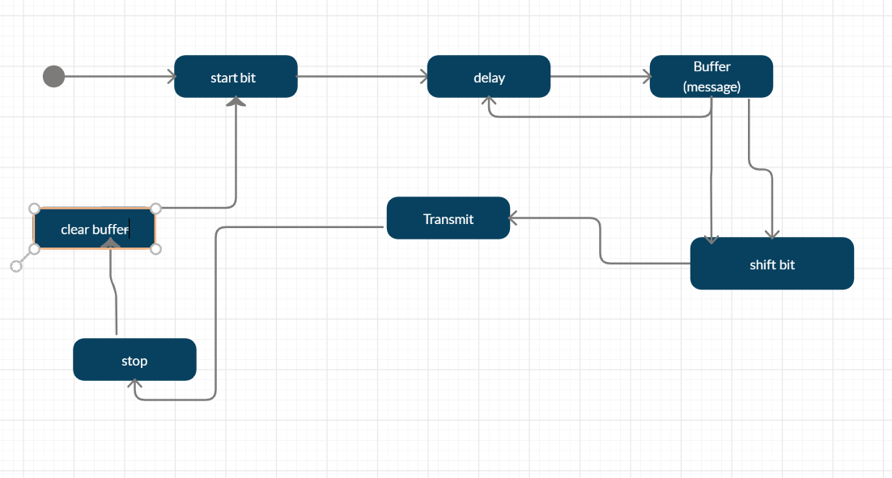

**Receiving**

When receiving the data we need first to consider the start bit to know that the bit is being received and after starting the bit we need to store bits received into our buffer. We also need to check the parity sent if it’s the same parity we have received and if the parity are the same that’s means that the bits sent are the same with the bits received.

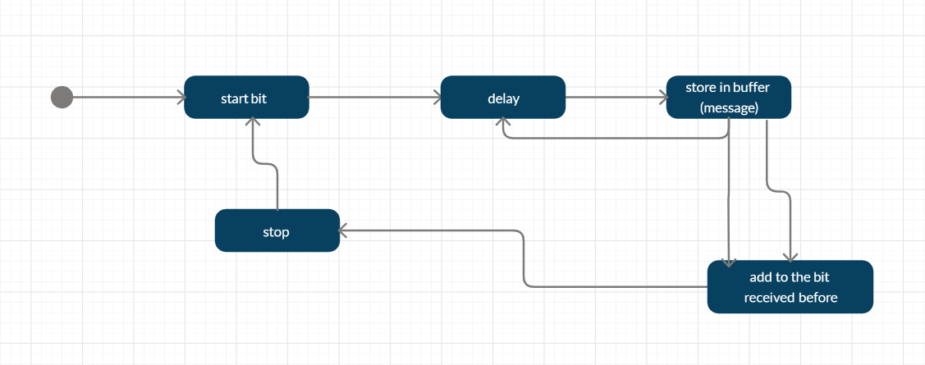

**Conlusion**

In conclusion we can say that UART is has some advantage and disadvantage and one of the advantages of UART is that it uses simple to understand because it is well documented and it uses only two wires and their disadvantage is that it uses small data frame.